Now I had added two more files and renamed the previous file on my git working directory

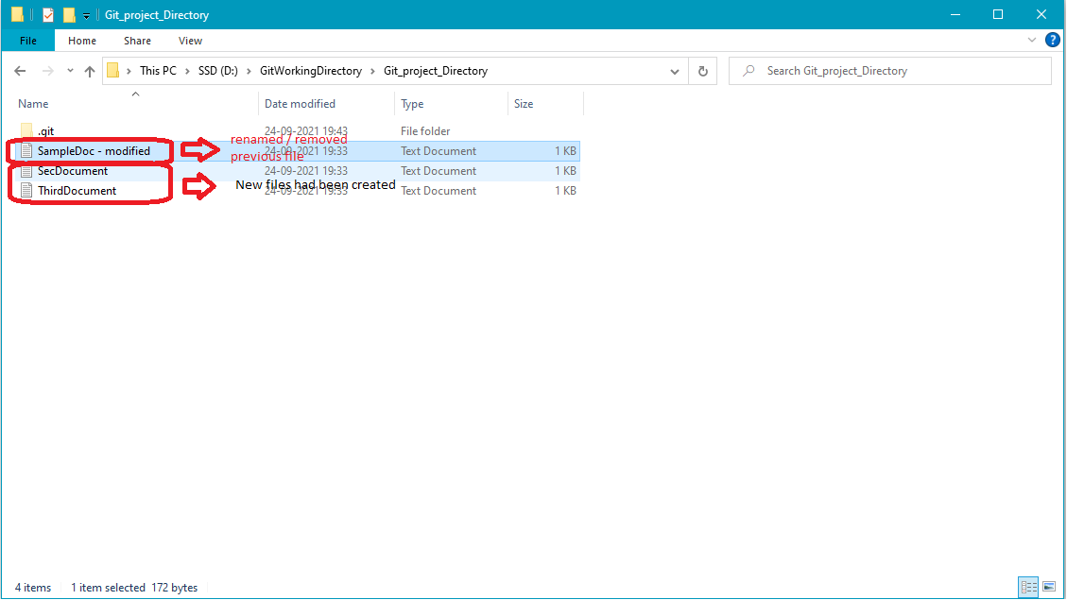

Now issue the command git status and observe the below changes.

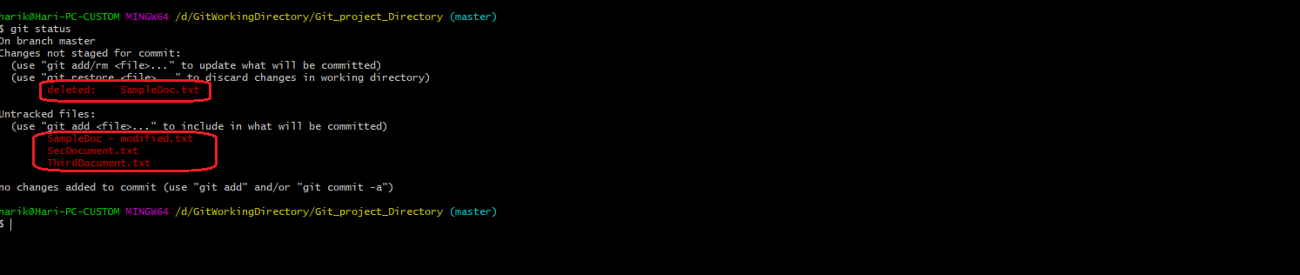

Now try to rename the previous file to its original name and check the git status.

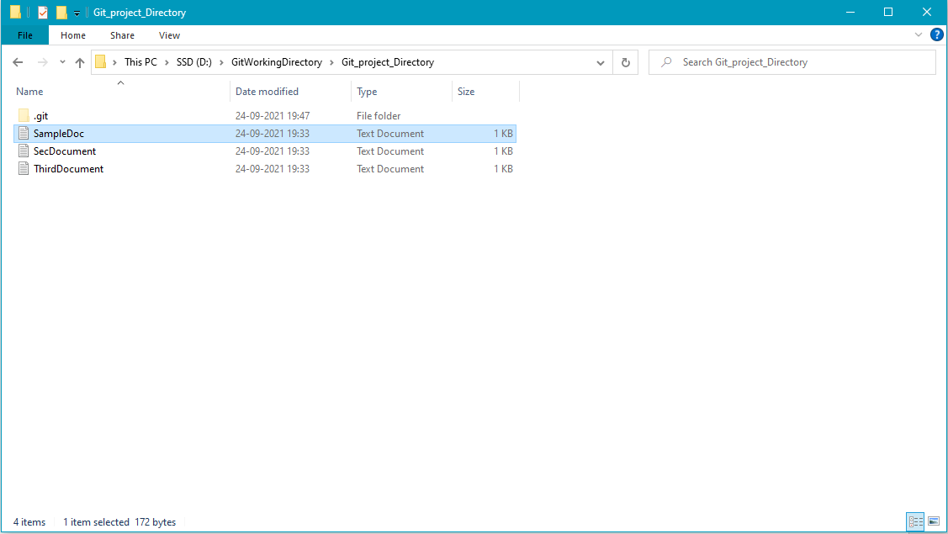

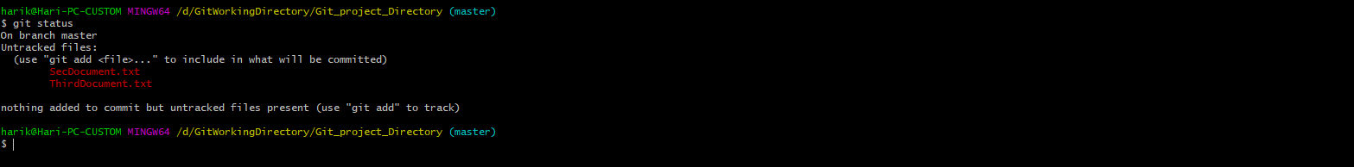

Note: After reverting back or placed the file, its showing only the untracked files as newely create files.

Now In order to verify what are all the commits happened for this repository, you need to view commit log by using the below command.

# git log

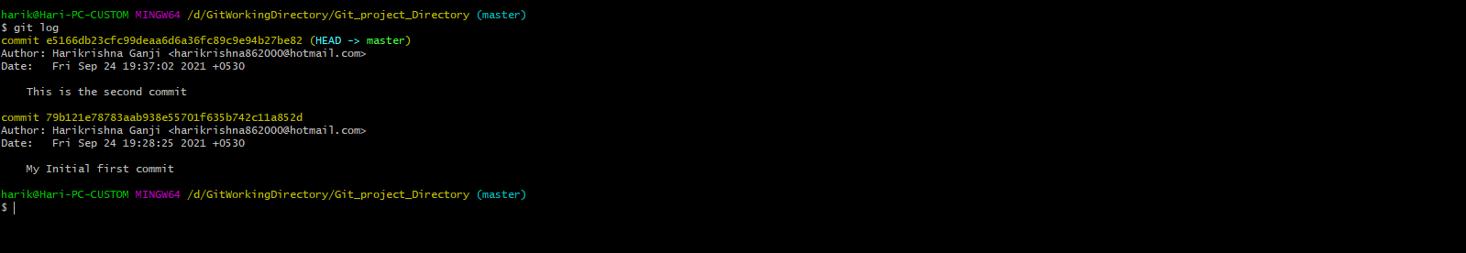

Note: You can see the separate ID at the line commit, which is called commit ID and those are used to switch back to particular git versions (we will see this at later).

Now if I want to see only the commits of a specific use that are committed up to now in this git repository, use the below command.

# git log --author=”Harikrishna Ganji”

